Lesson 2.2 – Compare Mixed Numbers

Standard: Number Sense 1.1– Compare and order positive and negative fractions, decimals, and mixed numbers and place them on a number line.

Objective: Students will be able to find common denominators and
rename MIXED fractions. Then use these new fractions to order and compare.

Vocabulary:

Mixed Number –

Example –

Proper fraction –

Example -

Improper fraction –

Example -

Example 1: Rename IMPROPER FRACTION as a MIXED NUMBER (& Proper Fraction) $\frac{27}{5}$

Step 1: $Divide 5 into 27$
Step 2: Take the remainder and place it above the denominator.

Practice:

1.) $\frac{23}{6}$ 2.) $\frac{39}{8}$ 3.) $\frac{15}{7}$

4.)$\frac{21}{20}$ 5.) $\frac{99}{4}$ 6.) $\frac{58}{21}$

Example 2: Rename MIXED NUMBER as an improper fraction $5\frac{1}{3}$

Step 1: Multiply the whole number with the denominator.
Step 2: Add the product to the numerator.
Step 3: The sum becomes the numerator.
Step 4: Place the denominator under the new numerator.
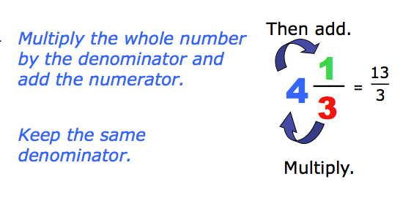
Think: M.A.D. (Multiply, Add, Denominator)

Practice:

1.) $3\frac{5}{8}$ 2.)$1\frac{1}{3}$ 3.)$4\frac{5}{16}$

4.) $2\frac{4}{9}$ 5.) $8\frac{6}{7}$

